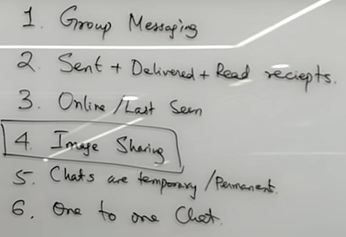

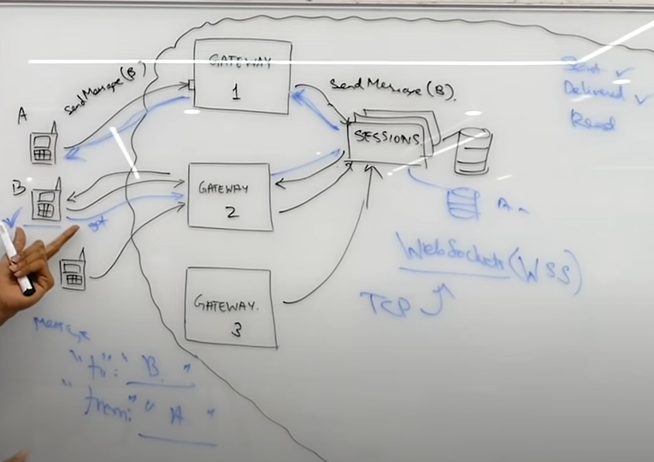

**Last Seen**

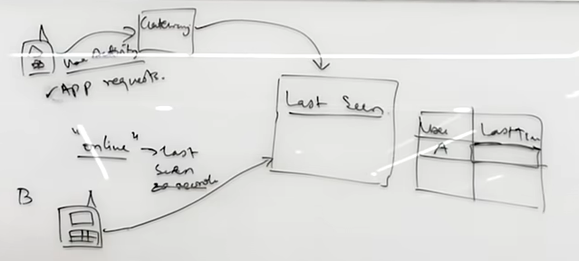

Functional Requirment

|  |  |
| --- | --- |
|  |  |

NonFunctional Requirement

1. Highly Availbality // service should be available for any request and should be fault tolarence
2. Scalable // service should handle load and number of users
3. Low lantancey // should not tak loger time to delever the msg
4. Durability // data should be temprory or retain longer time

* **API**
* registerUser(Userid) //can be mobile number for autontication using OTP
* validate(UserId)// validate OTP
* intiateDirectChat(userTo,UserFrom,Msg)
* SendMsg()
* getMsgStatus(msgId)
* readNewMsg(userIdTo,UserIdFrom,lastReadMsg)
* groupChat Msg
* intiateGroupMsg(userId,groupId)
* validateGruopWithUser(userId,groupId)
* AddUserToGroupe(groupId,UserId)
* removeUserFromGroup(groupId,UserId)